1. Go to –

<https://dev.mysql.com/>

1. Scroll down, on the left hand side pane under “**MySQL Community Server**” find click on version “**5.7.26 GA**”

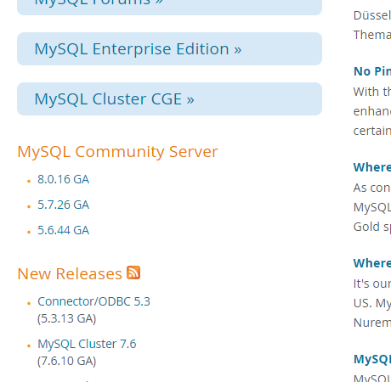

1. Scroll Down and “**Select the OS Version**” and click on “**Go to Download Page**” –

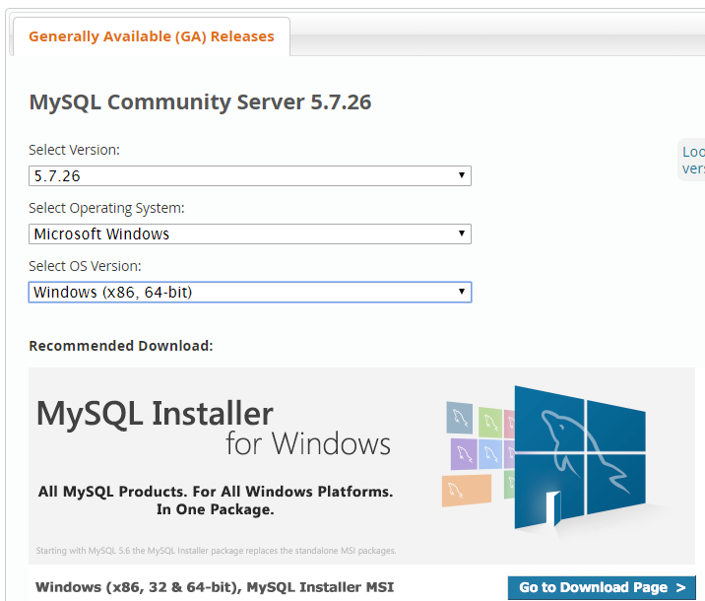

1. Scroll down and click on “**Download**” button against **MSI Installer** with *Higher Size* –

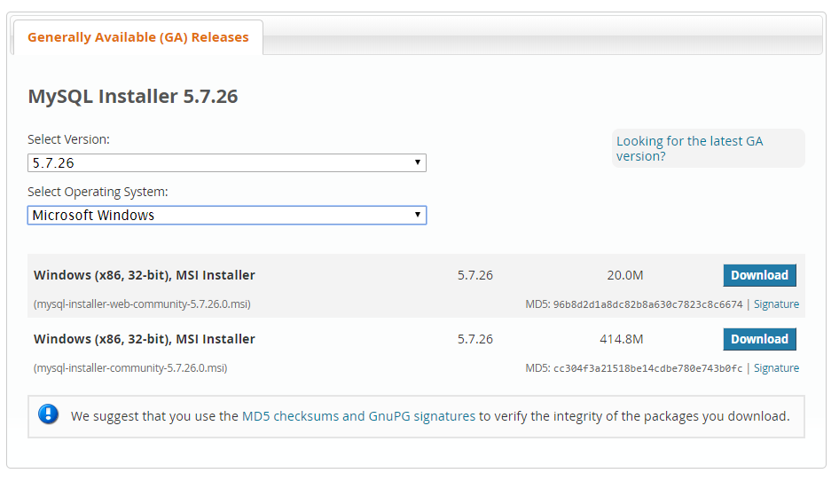

1. Scroll down and click on “**No thanks, just start my download**” –

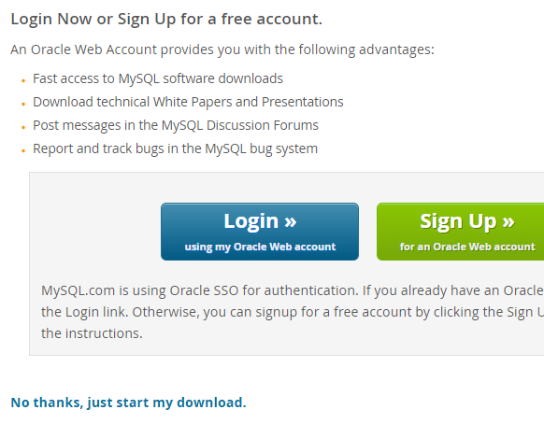

* *It will download “****mysql-installer-community-5.7.26.0.msi****” file.*

1. Once download finishes, **Run** above downloaded **.msi** file.
2. Check “I accept the license terms” checkbox and click on “Next” –

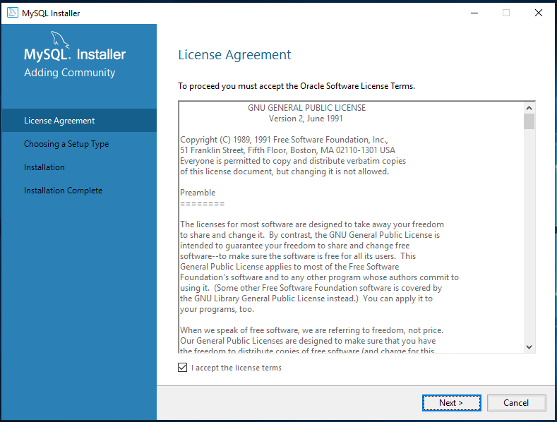

1. Select the “**Developer Default**” option and click on “**Next**” –

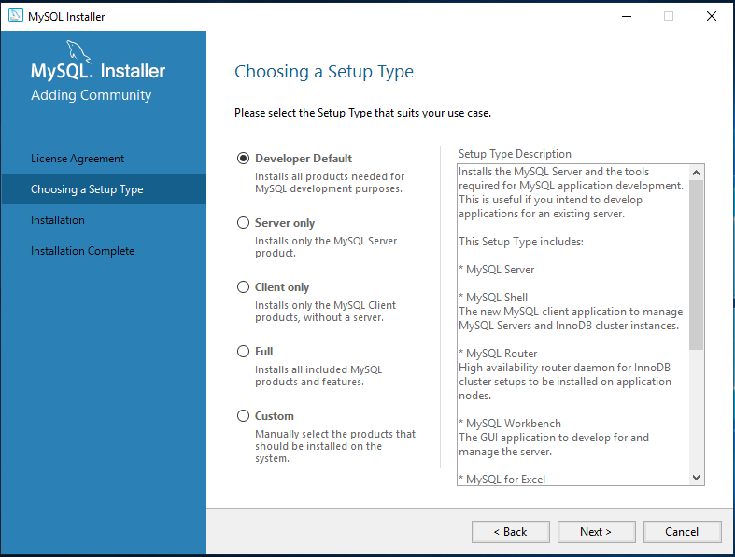

1. Click on “**Execute**” button –

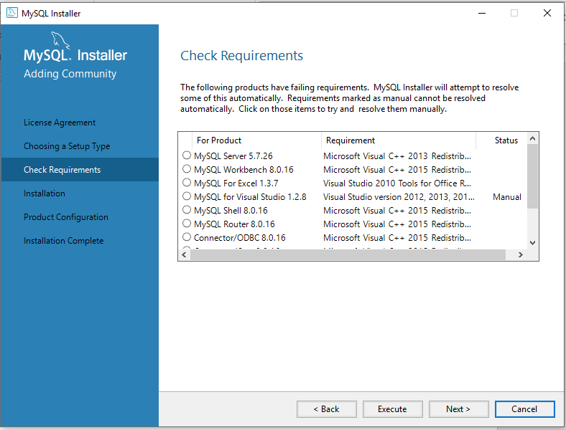

1. Click on “**Install**” on ***all the popups*** and “*install all the required applications”* –  
   [If no popup pops up, install all required software ***Manually*** (Follow ***Steps to Install Microsoft’s Applications Required for MySQL Installation***) ]

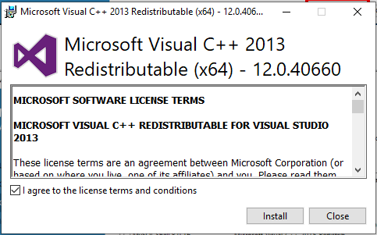

1. Once all required applications are installed, *ensure* ***Requirement for*** *at least* ***MySQL Server & Workbench*** is installed successfully.

* Click on “**Next**” –



1. If any popup pops up, click on “**Yes**” –s

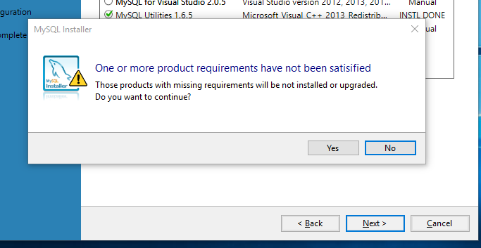

1. Click on “**Execute**” –

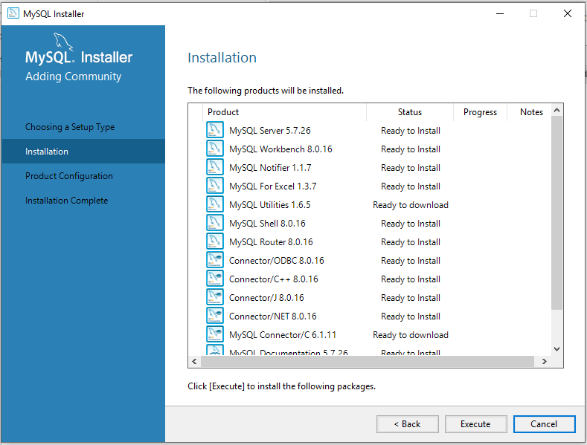

1. Click on "**Next**” –

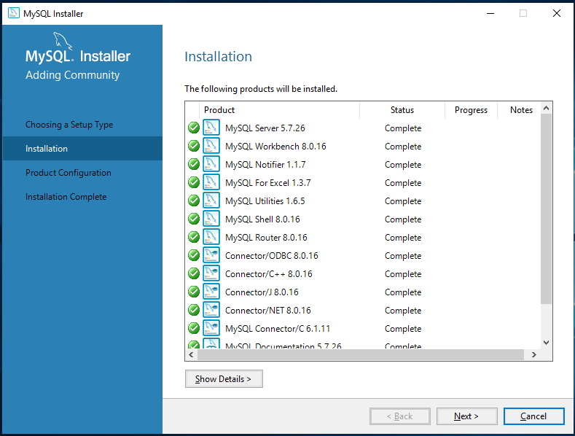

1. Click on “**Next**” –

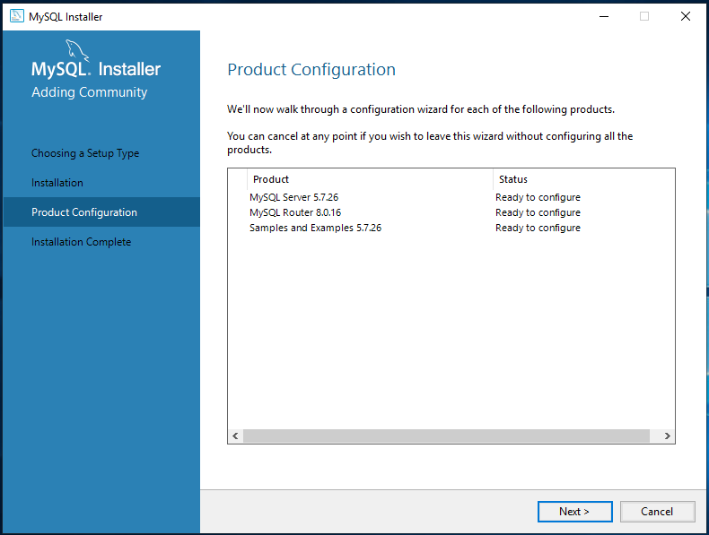

1. Select “***Standalone MySQL Server***” Click on “**Next**” –

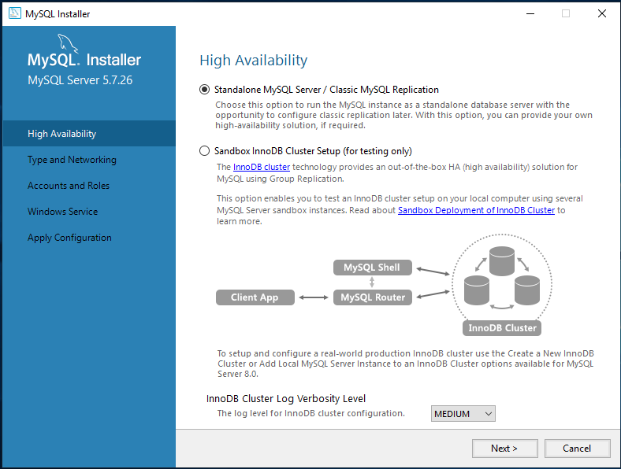

1. Note down the *“****port no.****”* and click on “**Next**” –

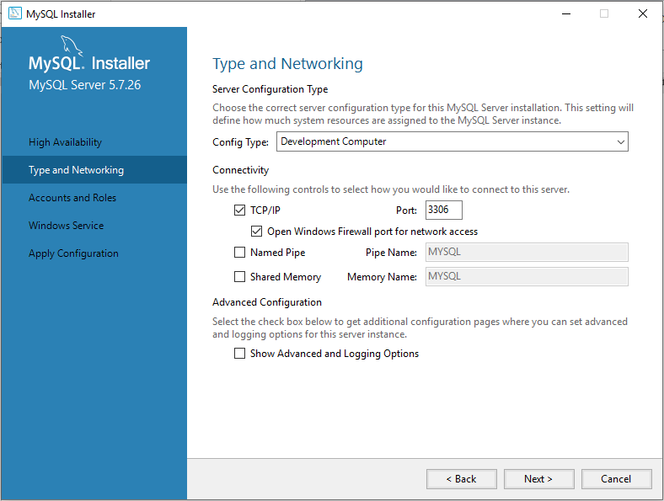

1. Set “root” account password to “**root**”.

* Click on “**Next**” –

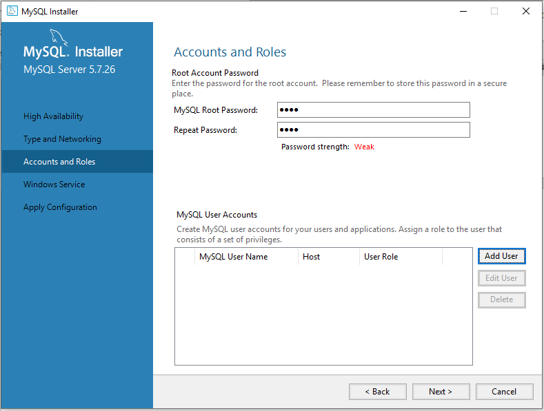

1. Click on “**Next**” –

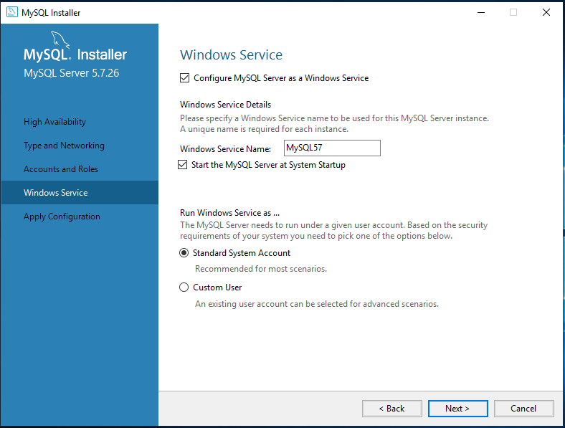

1. Click on “**Execute**” –

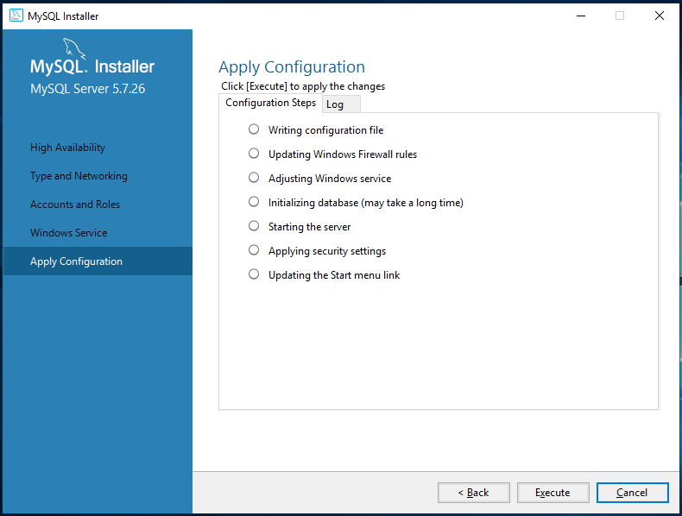

1. Click on “**Finish**” –

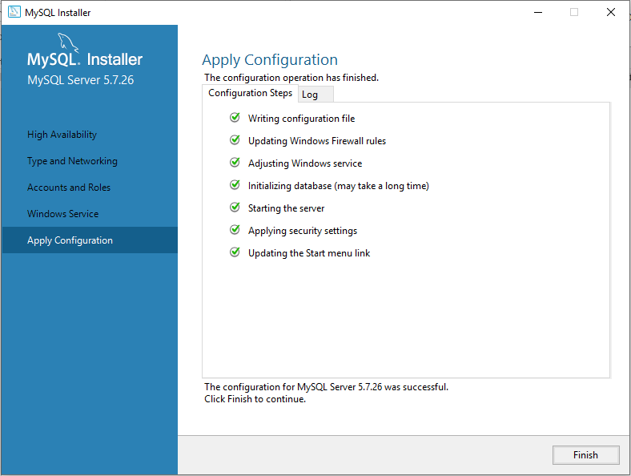

1. Click on “**Next**” –

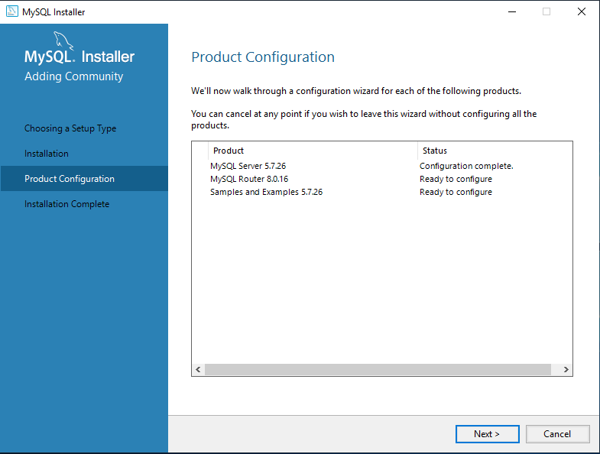

1. **Uncheck** *“Router for use with cluster”* checkbox then click on “**Finish**” –

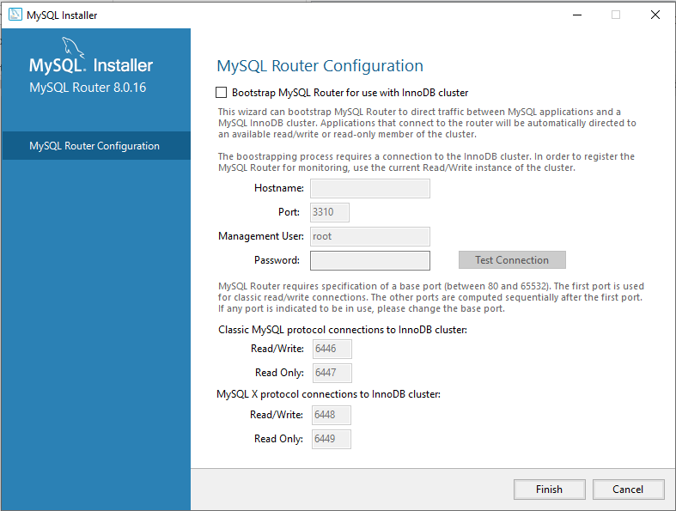

1. Click on “**Next**” –

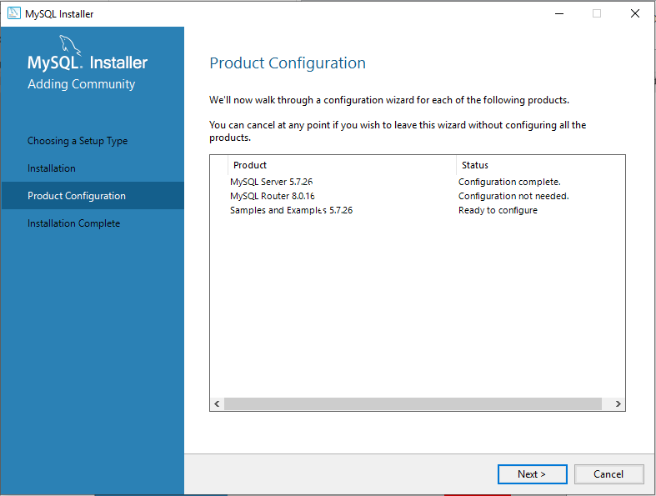

1. Enter “**Password:**” and click on “**Check**”.

* Next button will be enabled. Click on “**Next**”

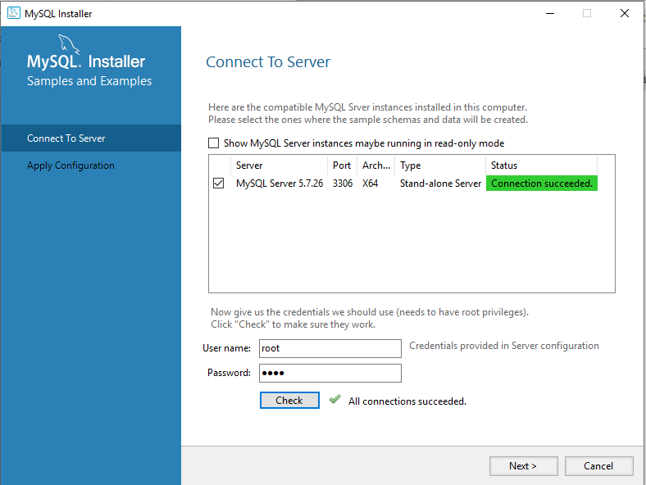

1

2

3

1. Click on “**Execute**” –

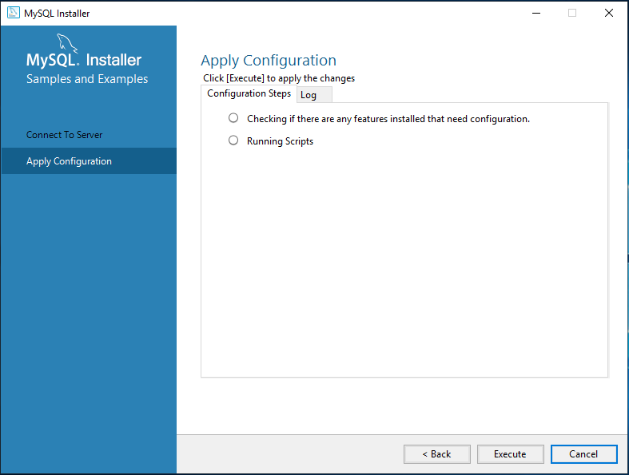

1. Click on “**Finish**” –

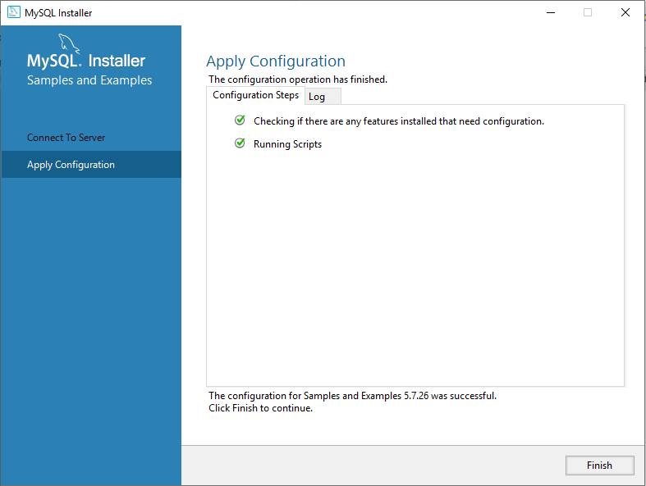

1. Click on “**Next**” –

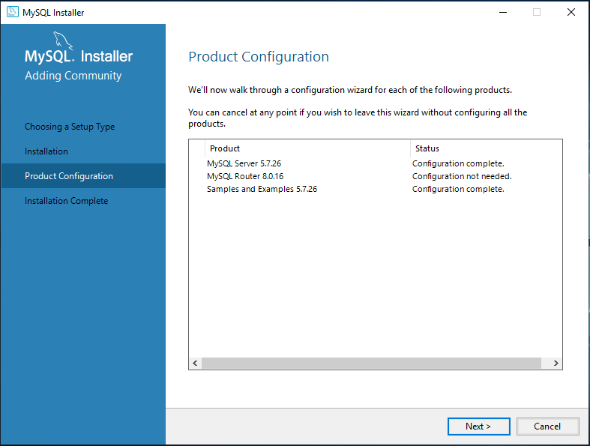

1. Based on your need, **Check / Uncheck** the checkbox(es) then click on “**Finish**” –

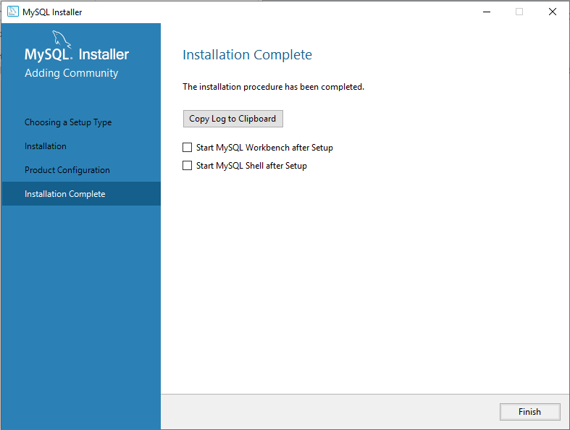

***Steps to Install Microsoft’s Applications Required for MySQL Installation***

1. Go to –

<https://www.microsoft.com/en-in/>

* 1. Click on “**All Microsoft**” 🡪 “**Free downloads & security**”

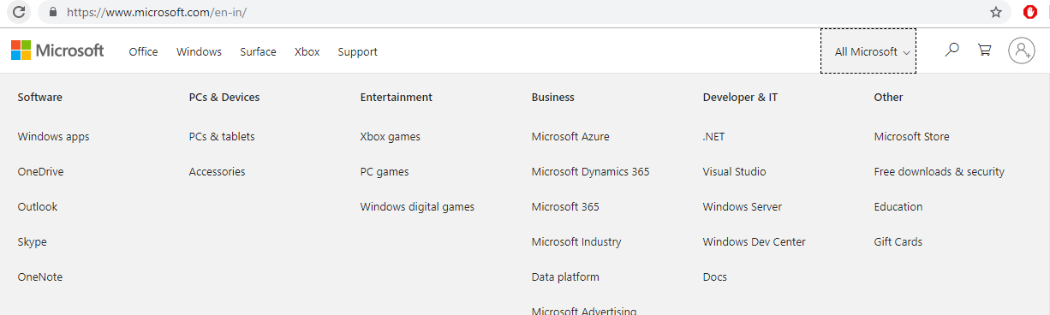

* 1. Scroll down and click on “**Developer Tools**” –

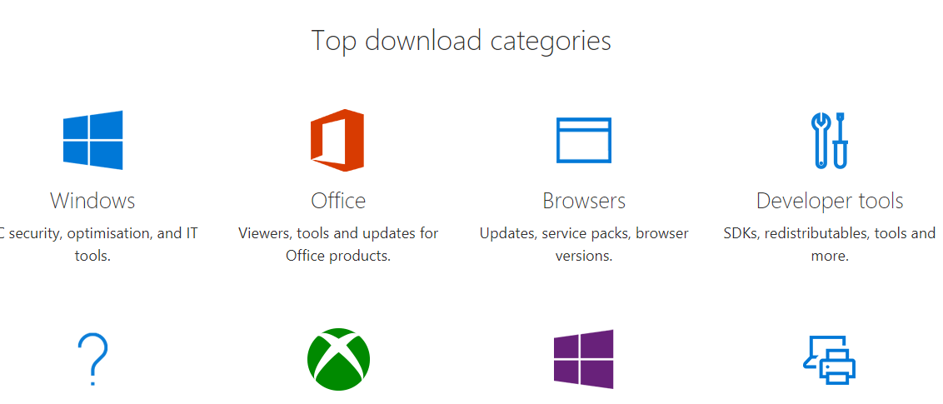

* 1. Scroll down and click on “**Visual C++ Redistributable for Visual Studio 2015**” -

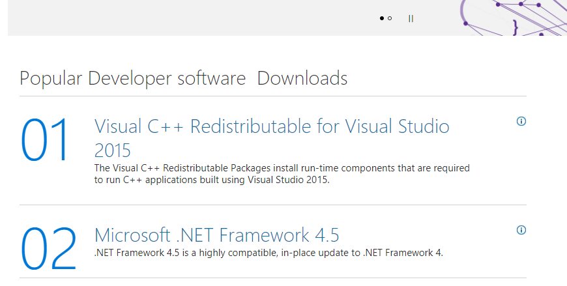

* 1. Click on “**Download**” button –

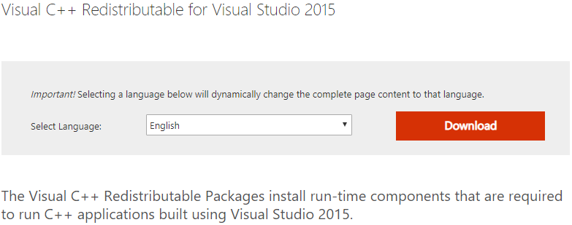

* 1. Select “**ve_redist.x64.exe**” for 64-bit windows OS and click on “**Next**” –

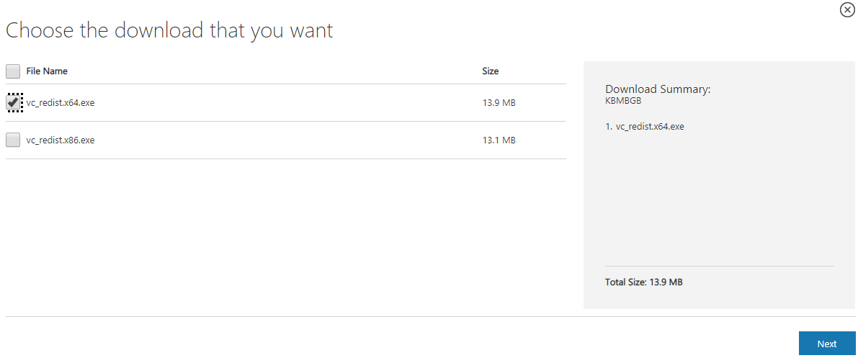

* 1. If download doesn’t start automatically, click on “Click here to download manually” link –

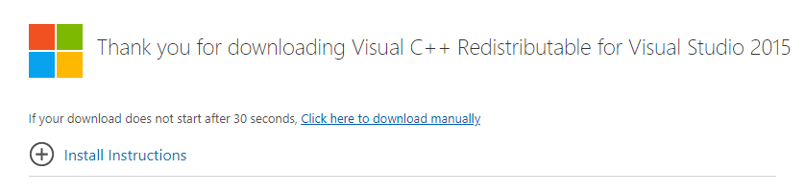

* 1. Click on “**Click here to download manually**” link against “**ve_redist.x64.exe**” –

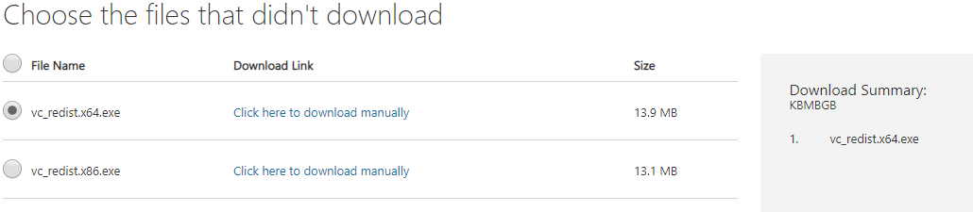

* It will download “**vc_redist.x64.exe**” file.
  1. Run this “**vc_redist.x64.exe**” file and “Install” Visual C++ 2015 –

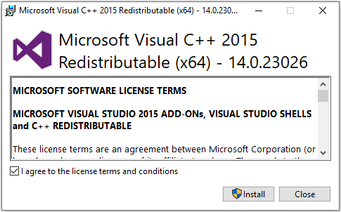

* 1. If asks for restart, Click on “**Restart**” –

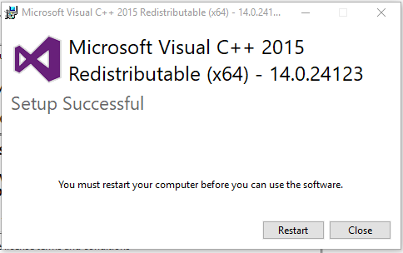

1. Go to –

<https://www.microsoft.com/>

* 1. Click on Search icon and search for “**Visual C++ 2013**”.

In the *‘search result window’* click on “**Explore**” –

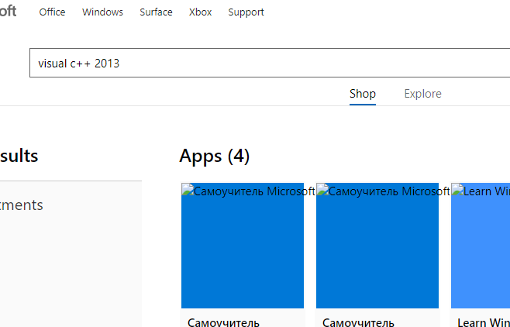

* 1. Click on “**Visual C++ Redistributable Packages for Visual Studio 2013**” link –

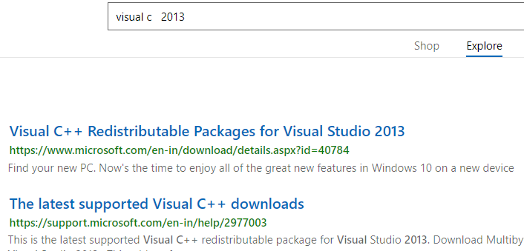

* 1. 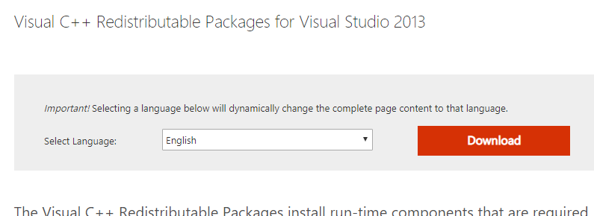Click on “**Download**” Button –
  2. Follow *“* ***Step: 30.e*** to ***Step: 30.i*** *”***.***(File name will be different).*

1. ***Similarly Install other software.***